Set Matrix Zeroes

Link:- <https://leetcode.com/problems/set-matrix-zeroes/description/>

Given an m x n integer matrix matrix, if an element is 0, set its entire row and column to 0's.

You must do it [in place](https://en.wikipedia.org/wiki/In-place_algorithm).

**Example 1:**

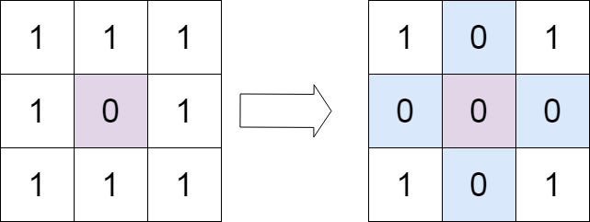

**Input:** matrix = [[1,1,1],[1,0,1],[1,1,1]]

**Output:** [[1,0,1],[0,0,0],[1,0,1]]

Solution:-

class Solution {

public void setZeroes(int[][] matrix) {

ArrayList<Integer> rows=new ArrayList<>();

ArrayList<Integer> column=new ArrayList<>();

for(int i=0;i<matrix.length;i++){

for(int j=0;j<matrix[0].length;j++){

if(matrix[i][j]==0){

rows.add(i);

column.add(j);

}

}

}

for(int i=0;i<rows.size();i++){

int a=rows.get(i);

for(int j=0;j<matrix[0].length;j++){

matrix[a][j]=0;

}

}

for(int i=0;i<column.size();i++){

int a=column.get(i);

for(int j=0;j<matrix.length;j++){

matrix[j][a]=0;

}

}

}

}